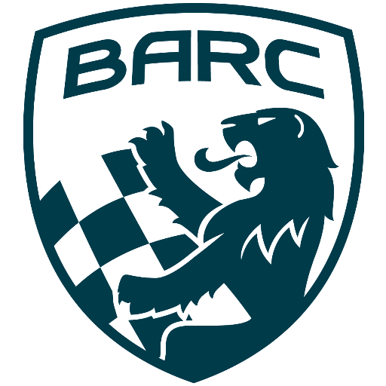

British Automobile Racing Club

General Membership Meeting Minutes – September 3, 2024

Venue - Texas Lone Star Grill, Dixon Road, Etobicoke, ON.

WELCOME – 20:12 Bryan Rashleigh, President

MINUTES

David King made a motion to accept the minutes of the previous meeting as if read, which was seconded by John Bordin and carried.

DEPARTMENTS

MEMBERSHIP Andrea Pegg, Membership Secretary

There are128 renewals and 26 new members.

TREASURY John Bordin, Treasurer

Our fiscal year end is September 30th. John would like to close the books as soon as possible.
The number of entrants at the BARC TT ensured we did not lose money.

WRRC/SOCIAL

Drive Festival will take place September 6th to 8th at CTMP.
CASC will have a booth and is looking for volunteers.

REGIONAL RACE/ORO John Bordin, Acting Race Director

The race went well, there were some learnings which will be applied next year.
John will hold a meeting with department heads to review the weekend on September 5th.

RACE COMMITTEE

John Bordin reported the CASC Annual General Meeting and banquet will take place on November 9th.
Effective on the Celebration weekend October 5th and 6th, CASC will take over timing at events from CTA.

HONDA INDY TORONTO David Bayley

There will be a review meeting with Department Heads on September 5th.

ICE RACING Wayne Wanamaker, Ice Race Organizer

There will be a Race Organizer meeting on September 12th.
The date for the BARC Ice Prix will probably be February 1st and 2nd.

TRS Tom Cressman

OTA has been sent the invoice for the TRS support at their event at the Driver Development Track at CTMP.

OLD BUSINESS

There was no old business.

NEW BUSINESS

David Brown bequeathed some money to BARC in his will. The Board will discuss how best to use it.
Andrew DePass a BARC member from the 70’s who was visiting his daughter in Canada from his home in Jamaica, was a guest at the meeting. He raced a Fiat 124 in the Bulova Series. He bought the car in Jamaica, sent it to Florida by boat and drove it from there to Canada. He spent 1972 and 1973 racing at Mosport. His name can be found on the Striling Moss award for 1973. He raced again in 1979 in a Formula Ford at Mosport, Watkins Glen and San Jovite.
One of his favorite memories from San Jovite was the first time he stood on a corner and watched Giles Villeneuve hit the same mark every lap. He pointed it out to his companion and said, “He is going to be a champion.”

Buy/Sell

John Jensen is selling a 1997 Ford F150 with an eight foot bed, v6 engine and extended cab. The vehicle has a bed liner and comes with extra rims and tires for $4000 to $5000.
Bryan Rashleigh has a 2000 watt iPower generator for $400.

Adjournment

Wayne made a motion for adjournment which was seconded by John Bordin at
20:53.

NEXT MONT H’S MEETING: at the Lone Star Texas Grill (upstairs) – October 1st, 2024, at 20:00.

