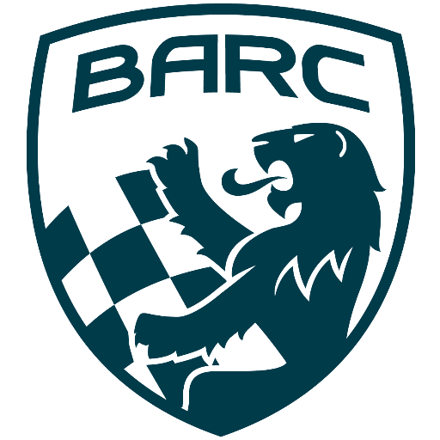

British Automobile Racing Club

General Membership Meeting Minutes – October 1st, 2024

Venue - Texas Lone Star Grill, Dixon Road, Etobicoke, ON.

WELCOME – 19:47 Bryan Rashleigh, President

MINUTES

Amy Harrison made a motion to dispense with the reading of the minutes, which was seconded by Jennifer Graham and carried.

DEPARTMENTS

MEMBERSHIP Andrea Pegg, Membership Secretary

There are currently 155 members with 128 being renewals.

TREASURY John Bordin, Treasurer

Our finances are up to date, with all invoices paid.
John will discuss possibly buying more GICs with the Board.

WRRC/SOCIAL

There is nothing to report.

REGIONAL RACE/ORO John Bordin, Acting Race Director

We had a successful weekend.
This was John’s first attempt at planning a race weekend. He held a post-race review with Department Heads. There were quite a few learnings, which will be used in future race planning.
Those in attendance thanked John for his efforts in planning a successful weekend.

RACE COMMITTEE

There were discussions about the number of people who were passing under yellow.
A suggestion was made to put cameras in all cars showing both the front and rear view. While this will be helpful in investigations, not everyone may be able to afford it.
The CASC Annual General Meeting will take place on November 9th. Information can be found here: www.casc.on.ca/all/casc-or-annual-members-meeting-announcement-november-9th-2024

HONDA INDY TORONTO David Bayley

There was a post-race meeting with Department Heads. The information gained will be used in future planning.

ICE RACING Wayne Wanamaker, Ice Race Organizer

The BARC Ice Prix will take place on February 8th and 9th in 2025.
CASC will implement a cost sharing plan for the 2025 season. They will cover the cost of insurance, the permit, track rental and medical personnel. They would take in the revenue and share it with clubs at the end of the season.
BARC will continue to pay for the volunteer dinner, meals at the track and accommodation.

TRS Tom Cressman

Training is being planned for next year.

NEWSLETTER

Please submit any items of interest to club members to Amy Harrison.

OLD BUSINESS

There was no old business.

NEW BUSINESS

Rick McLeary, Amy Harrison’s dad showed his Austin Healey at the British Car Day at Bronte Creek Provincial Park on September 15th and placed second in his class.
Bryan and Jonathon Rashleigh went to HIP Motorsports for some SIM racing and had a great time. Included in the available tracks is CTMP which they ran and highly recommend.
Phil Delahaye mentioned, in Japan as part of driving training before getting your licence, you are required to train on a simulator. These can simulate poor driving conditions, including snow and rain.
Buy/Sell

There was nothing to buy or sell.

Adjournment

Wayne made a motion for adjournment which was seconded by Peter Corley at
20:23

NEXT MONT H’S MEETING: at the Lone Star Texas Grill (upstairs) – November 5th, 2024, at 20:00. Please note this is the Annual General Meeting and if you cannot attend, your proxy ballot can be sent to the Secretary at secretary@barc-oc.com

