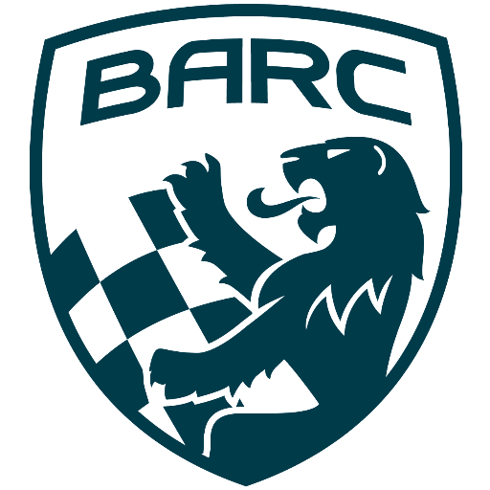

British Automobile Racing Club

General Membership Meeting Minutes and AGM – November 05, 2024

Venue - Texas Lone Star Grill, Dixon Road, Etobicoke, ON.

WELCOME – 20:18 Bryan Rashleigh, President

MINUTES

David King made a motion to dispense with the reading of the minutes which was seconded by Wayne Wanamaker and carried.

DEPARTMENTS

MEMBERSHIP Andrea Pegg, Membership Secretary

There are currently155 members with 128 being renewals.

TREASURY John Bordin, Treasurer

John sent his regrets and there was no report.

WRRC/SOCIAL

The CASC AGM and banquet will take place on November 9th.

REGIONAL RACE/ORO

CASC Annual Awards will be handed out on Saturday night, November 9th.

RACE COMMITTEE

There was nothing to report.
HONDA INDY TORONTO David Bayley

There is nothing new to report at this time.

ICE RACING Wayne Wanamaker, Ice Race Organizer

The BARC Ice Prix will take place on February 8th and 9th in 2025.

TRS Tom Cressman

There will be the usual training in April.

OLD BUSINESS

Bryan has been in communication with the British BARC club and has sent some information for their newsletter.

NEW BUSINESS

There was a new member present, Russo is interested in competing in CASC Region Racing.

Buy/Sell

Jennifer Di Francesco has a couple of cadet carts for sale.

At 20:32 Tom Cressman made a motion to start the Annual General Meeting.

At 20:33 Tom made a motion to dispense with the reading of the 2023 AGM minutes, which carried.

Bryan then read the Board members reports.

Bryan Rashleigh, President
As President, Bryan is the chairperson for Membership and Board meetings. He assists Board members with their roles when necessary. He represents BARC in meetings with CASC and other clubs and organizations. He organizes the trophies for the club’s races and annual awards presentations. Bryan also looks after the BARC regalia, decals, and crests. He represents BARC at CASC meetings. As a competitor, he advises the Board on matters from a driver’s point of view. Bryan represents BARC on the CASC Race Committee.

Kyle Bast, Vice-President
As Vice-President, Kyle supports the President, the Board and fills in for the President when he is not available. He works with the members of the Board to discuss issues relating to and helps to make decisions in the best interest of the club. Kyle also advises the board on medical supplies and any updates in legislation in relation to health and safety. Kyle supports the Doctor at race events, ensuring he is equipped with a radio and necessary supplies for the events. Kyle is also a member of the Track Rescue Team and is responsible for the upkeep of training and supplies for the team.

John Bordin, Treasurer
As Treasurer, John works with the Board to manage expenditure and the club’s finances. John works with the Finance Review Committee, to review safety controls and processes. He pays all invoices for the club, following established club protocols. He provides the finances, with Board approval, to the BARC Race Directors for all race expenses. He also works with the Membership Secretary to reconcile membership payments between the club and CASC files. John also produces reports on the club’s finances to be presented at both Membership and Board meetings. He is the gatekeeper of club spending and advising the Board on expenditure. John is filling in as acting Treasurer and will be running for the position in this election.
John is the acting BARC Race Director. In this role, he is responsible for negotiating the date for the BARC TT, organizing the races, schedule, volunteers, and additional service providers to run a successful race weekend. He works with the Motorsport Marshalling Services and the Canadian Timing Association to provide support for the race weekend. John also provided race management support for the VARAC Peter Jackson Races, with other BARC members.

David Bayley, Secretary
David is responsible for reporting and maintaining records on Membership and Board meetings. He disseminates information to club members when necessary. David prepares and distributes documents for the AGM to members. He answers e-mails from members, other clubs and interested parties, on behalf of the club. David is also the Secretary for the BARC volunteers at the Ontario Honda Dealers Indy Toronto.

Andrea Pegg, Membership Secretary
Andrea accepts and records paid memberships. Maintains the records and updates the Board and Membership of the current standings at meetings. She reconciles records against the CASC files. She sends welcome e-mails to new and renewing members. Andrea sends out membership hard cards to those requesting them. She reconciles payments with the Treasurer to ensure all payments are captured. Additionally, as a member of the Track Rescue Services team, Andrea supplies team members with safety clothing and equipment. Where necessary, she gets Board approval to replace older and defective items. She also assists with organizing the annual training for TRS members.

Wayne Wanamaker, Director
As a member of the Board, Wayne is responsible for attending Board meetings and offering input and suggestions on running the club. Wayne is also the BARC Ice Race Director. He is responsible for organizing all aspects of the BARC Ice Race, including providing volunteers for the event. He is also a member of the CASC Ice Race Organizers Committee, where he is the Secretary and records all meetings. Wayne attends all Board and Members’ meetings, where he has assumed the role of the person making the motion for adjournment at all meetings.

Scott Ellsworth, Director
Along with providing input and recommendations on Board decisions. Scott is an advisor to the club on al race matters. He takes care of the BARC website.
Tom Cressman, Director
In his role on the Board, he provides input and recommendations to the Board. Also, he is involved with decision making on club affairs. Tom is also the Track Rescue Services, Team Lead. In this role Tom and his team provide support for BARC, Ontario Time Attack and Honda Indy Toronto events. He also advises the Board on track safety issues. He recruits new volunteers with Kyle and Andrea to the TRS team. Tom insures they are fully trained. He also reviews safety equipment and advises the Board on required items.

John Jensen, Director
John had a one-year term after filling in for Howard Cohen who stepped down from his role as director. He takes pictures at BARC events, is a region scrutineer and works with the Board to make decisions on behalf of the club.

Bryan made a motion to accept the actions of the Board, which was seconded by David King and carried.
The Financial Statements for 2022 and 2023 are ready and awaiting review by the Financial Review Committee. They will be presented at a future meeting.

The positions up for election were President, Secretary and Treasurer.

Bryan ran again for his position as President. There were no other nominations, and David King made a motion to close nominations, which was seconded by Bob Page and carried. Bryan will continue as President.

David Bayley again ran for Secretary and with no challengers, Keith Whorley made a motion to close the nominations which was seconded by Greg Clement and carried. David will continue as the Secretary.

John Bordin who has been the acting as the Treasurer ran for the position. With no challengers, Greg Clement made a motion to close the nominations which was seconded by Bryan and carried. John will change from the acting to the Treasurer position.

Adjournment

Wayne Wanamaker made a motion for adjournment which was seconded by Tom Cressman at 21 :05

NEXT MONTH’S MEETING: at the Lone Star Texas Grill (upstairs) – December 4th, 2024, at 20:00.

