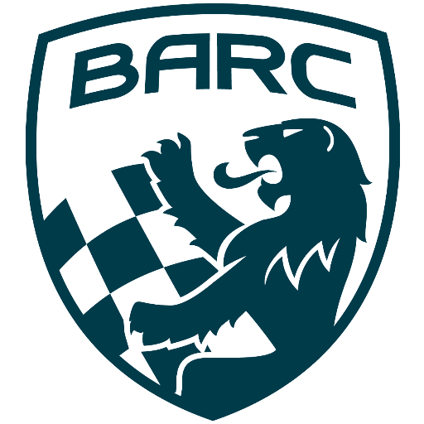

British Automobile Racing Club

General Membership Meeting Minutes – July 2nd, 2024

Venue - Texas Lone Star Grill, Dixon Road, Etobicoke, ON.

WELCOME – 20:05 Bryan Rashleigh, President

MINUTES

Amy Harrison made a motion to accept the minutes of the previous meeting, which was seconded by Pat Harrison and carried.

DEPARTMENTS

MEMBERSHIP Andrea Pegg, Membership Secretary

There are currently 100 renewing members and 23 new members.

TREASURY John Bordin, Treasurer

John has paid the insurance and permit invoices for the BARC TT. The ambulance invoice is to be paid.

WRRC/SOCIAL

There is currently nothing new to report.

REGIONAL RACE/ORO Race Director

John Bordin has taken the lead in the planning for the BARC TT and the VARAC
one-day event. Things are moving along well, Kyle Bast is arranging for the doctor, nurse, ambulance and towing.

RACE COMMITTEE

There is nothing to report.

ONTARIO HONDA DEALERS INDY TORONTO David Bayley

The MotorsportReg registration for the event is open.

ICE RACING Wayne Wanamaker, Ice Race Organizer

Organizers are meeting next week.

TRS Tom Cressman

Tom showed an example of the new TRS fire suits.
Kyle Bast and Tom went to Conestoga College to speak to the students in the firefighter course. Some of them were among the new volunteers who were trained at Flamboro Speedway in April. Nina, Onkar, Sydney and Cam were at the meeting and are now BARC members.

OLD BUSINESS

There was no old business.

NEW BUSINESS

Long term member David Brown has lost the battle with his health issues.
In June Robert Wickens tested an adapted Formula E racecar at Portland International Raceway.

Buy/Sell

There was nothing to report.

Adjournment

Wayne made a motion for adjournment which was seconded by Tom Cressman at 20:37
.
NEXT MONTH’S MEETING: at the Lone Star Texas Grill (upstairs) – August 9th, 2024 at 20:00.

