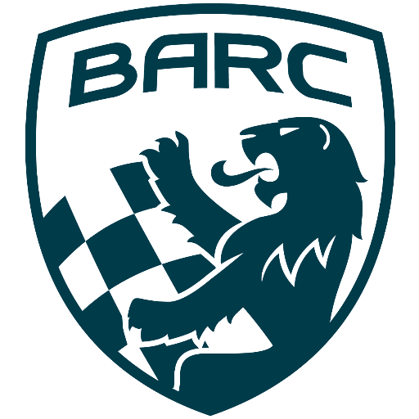

British Automobile Racing Club

General Membership Meeting Minutes – August 6th, 2023

Venue - Texas Lone Star Grill, Dixon Road, Etobicoke, ON.

WELCOME – 20:10 Bryan Rashleigh, President

MINUTES

David King made a motion to accept the minutes of the previous meeting as if read, which was seconded by Paul Einarson and carried.

DEPARTMENTS

MEMBERSHIP Andrea Pegg, Membership Secretary

There are 100 renewing and 23 new members.

TREASURY John Bordin, Treasurer

We are in good shape financially.
The BARC TT was one of the best attended events in years.
Tom Hyland and Anne McCallum are working on the reconciliation from the event.
The breakfast was partially subsidized by CASC. The dinner was partially subsidized by an anonymous donor.
BARC has given their usual donation to Team Canada to help with expenses on their trip to the UK for the Formula Ford Festival.

WRRC/SOCIAL

There is nothing to report.

REGIONAL RACE/ORO John Bordin, Race Director

John Bordin stepped up to fill in for Scott Ellesworth who has stepped down as Race Director.
The BARC TT went well, there were some learnings from the weekend. This was an education and will inform planning for the future.
The Peter Jackson race did not have many entries, but it was a great one-day event.
Bryan thanked everyone who helped at both events. He also thanked John for leading in the planning of the events.

RACE COMMITTEE

There was no report.

HONDA INDY TORONTO David Bayley

The Indy went well. Here are some highlights:

- some of our regular attendees in key roles, including Department Heads could not attend this year
- experienced people stepped up into the role of Department Head, to keep things rolling along
- there were more Marshalls this year, than in many previous years
- the Track Rescue Team, had a large number of new well trained young recruits
- children of long-term volunteers were now participating
- as usual there were new challenges, but everyone stepped up to make the event a success
-TRS staff suggested we invite the other rescue teams to attend the BARC workers’ dinner, and they thanks us and enjoyed the food

ICE RACING Wayne Wanamaker, Ice Race Organizer

The next Ice Race meeting is September 12th.
CASC is looking for an Ice Race director.
The rules are being reviewed.
For 2025 there will be no spec stud tire. However, the number of studs in the different brands of tires vary, so further discussion is needed..

TRS Tom Cressman

Things were very busy at the Indy and the team ended up on television helping with the big accident near the end of the race.

OLD BUSINESS

There was no old business.
NEW BUSINESS

Paul Einarsen and Keith Whorley said the hotels around CTMP have become very expensive. Keith suggested the club reserve a block of rooms, if we can get a better rate. We will investigate for next year.
David King stayed in Peterborough where the rates are more reasonable.
Paul also suggested we look at alternative sources for food as the prices have become excessive.
David suggested checking with VARAC to see where they get their food.
The Drive Festival will be held at CTMP on September 6, 7 and 8.

Buy/Sell

Paul Einarsen has a Firebird convertible for sale.
David King has a corner cabinet for sale. Please contact them directly if you are interested.

Adjournment

Wayne made a motion for adjournment which was seconded by John Jensen at
21:10.

NEXT MONT H’S MEETING: at the Lone Star Texas Grill (upstairs) – September 3rd, 2024, at 20:00.

