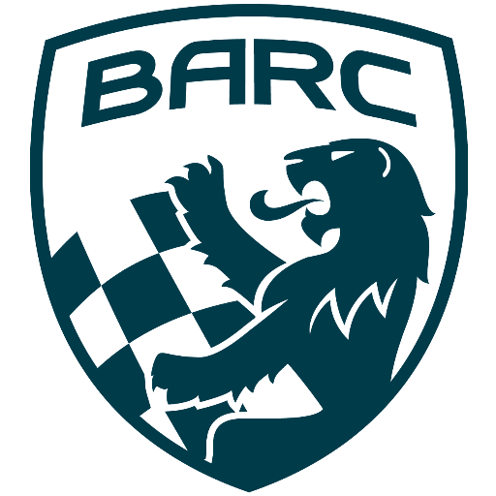

British Automobile Racing Club

General Membership Meeting Minutes – May 7th, 2024

Venue - Texas Lone Star Grill, 930 Dixon Road, Etobicoke, ON.

WELCOME – 20:04 Bryan Rashleigh, President

MINUTES

Paul Einarson made a motion to accept the minutes of the previous meeting as if read, which was seconded by Jack White and carried.

DEPARTMENTS

MEMBERSHIP Andrea Pegg, Membership Secretary

There are currently 128 members with 14 being new. There were 143 members at the same time last year.

TREASURY John Bordin, Treasurer

John reported BARC can now do e-transfers.
He received a refund from the insurance company due to the Ice Prix being cancelled.

WRRC/SOCIAL

Nothing to report.

REGIONAL RACE/ORO Race Director

The BARC TT will take place at CTMP on July 26th and 27th.
BARC needs a Race Director, Jack White suggested we present a job description and someone may be interested. If anyone is interested, please send Bryan an e-mail.

RACE COMMITTEE

Miata Canada Cup series was discussed.

ONTARIO HONDA DEALERS INDY TORONTO David Bayley

The event has a new sponsor this year and will be called the Ontario Honda Dealers Indy Toronto.

ICE RACING Wayne Wanamaker, Ice Race Organizer

Due to revenue losses by clubs this year, there will be a new process next year, whereby CASC will manage the money and split fixed costs. There will be a revenue sharing program with the clubs.
As usual there is a push to create more interest in Ice Racing, one of the ideas is to have a Minden shop teacher work with students to build a car and race it.

TRS Tom Cressman

TRS had their annual training for the upcoming season. There was training including, mock crashes, extrication, hands on fire suppression, first aid and medical.
Abrams Towing was there as advisors in handling vehicles involved in a collision.
They used the new sweeper and it worked well.
TRS has a new logo and a new suit supplier. The supplier has opened an online store for TRS members allowing them to buy TRS merchandise.
They have purchased radios for their internal communication at events. BAST Emergency Services has purchased eight channels which can be used by TRS at any of the events they support.
They continue to support Ontario Time Attack events in 2024.

OLD BUSINESS

There was no old business.

NEWSLETTER

Amy has received no submissions so there was no newsletter.

NEW BUSINESS

New member David Walsh was introduced at the meeting. Nora Cressman is training with TRS.
There was a request to clean up the main page of the BARC website as some of the news is old.
John Bordin will present the financial statements at the June meeting.
John Jensen took his new racecar to Toronto Motorsport Park for an open lapping day. He left some brochures on BARC with the Registration staff and had the pleasure of meeting and old acquaintance, former racer and sportscar dealer Uli Bieri,

Buy/Sell

There was nothing being bought or sold.

Adjournment

Wayne Wanamaker made a motion for adjournment which was seconded by Andrea Pegg at 20:44.
.
NEXT MONTH’S MEETING: at the Lone Star Texas Grill, 930 Dixon Road(upstairs) – June 4, 2024, at 20:00.

